# A Mathematical Object for Coordinate System Transformation

***Abstract***: Matrix operations are often used in coordinate system transformations, while tensor operations are utilized in more general situations. The former belongs to the category of "element" mathematical objects, which are not designed for coordinate system transformations and have problems with redundancy and convenience in the calculation process. The latter is difficult to master and challenging to use numerically. This paper introduces a specialized structure object for coordinate system transformation as a substitute for matrix and tensor operations.

## Introduction

Coordinate systems have always been the most abstract and difficult mathematical and physical objects, and the development of tensor operations has made them even more abstract, requiring years of training to barely master. Therefore, it is necessary to explore a simplified method to address the challenges of coordinate system operations. Although matrix operations are commonly used in coordinate system transformations, they are not designed for this purpose and are too mathematical and vague in meaning. Tensors, on the other hand, are too abstract and difficult to master, and it is difficult for computers to quantify them. A concept specifically designed for coordinate system transformation is needed.

## Design

A mathematical object named "coord" is designed based on group theory to perform arithmetic operations. The definition of the coordinate system structure is as follows: a three-dimensional coordinate system consists of an origin, three directional axes, and three scaling components, representing translation, rotation, and scaling transformations.

#### Definition of coordinate system structure:

* The coordinate system in three-dimensional space consists of an origin plus three direction axes and three scaling components, corresponding to the three transformations of **translation, rotation, and scale,**  respectively (C++ version):

struct coord

{

vec3 ux, uy, uz; Three unit basis vectors

vec3 scale; zoom

vec3 o; Origin Position

}

Construct a coordinate system object (C++ version).

By three axes

coord C(vec3 ux, vec3 uy, vec3 uz)

coord C(vec3 ux, vec3 uy);

By Euler angles

coord C(float angle, vec3 axis);

coord C(float pitch, float yaw, float roll);

(Origin and scaling can be directly set)

#### Multiplication: Define a vector in a certain coordinate system

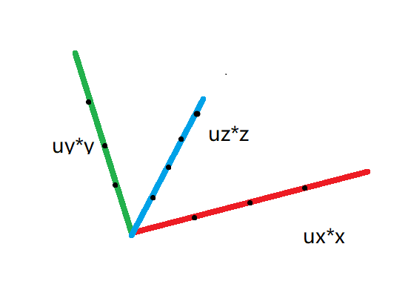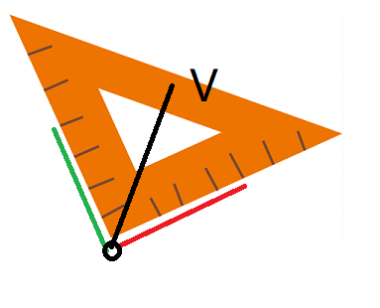

Use multiplication to transform a vector from the local coordinate system to the parent coordinate system and to merge coordinate systems.

For example: V0 is defined in the world coordinate system C0, and V1 is defined in the C1 coordinate system.

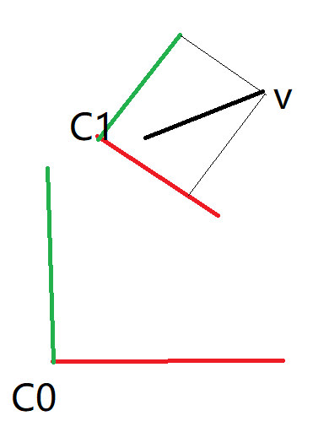 V0 = V1 * C1

C1, C2, and C3 are local coordinate systems in three scene nodes, and the parent-child direction is:

V0 = V3 * C3 * C2 * C1 = V3 * (C3 * C2 * C1)

Multiplication after swapping with vectors:

V * C != C * V

Define the coordinate system and multiply the vector:

C * V = Lerp(ONE, C, V.dot(UX))

where Lerp is a linear interpolation function and

ONE = coord. ONE, UX = vec3. UX

#### Division: Measure a vector using a certain coordinate system

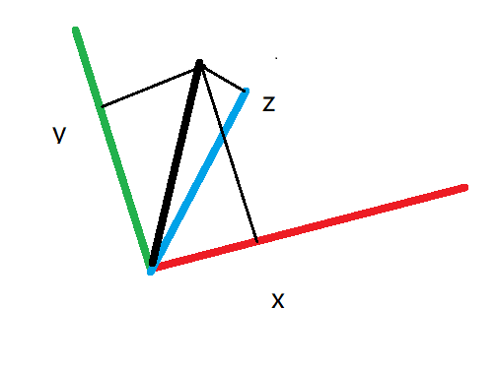

Use division to project from the parent coordinate system to the local coordinate system. For example:

V0 is defined in the world coordinate system C0, and V1 is defined in the C1 coordinate system

V1 = V0 / C1, V0 = V1 * C1

V2 is defined in the C2 coordinate system:

V2 = V0 / C2 = V1 * C1 / C2

C1, C2, and C3 are local coordinate systems in three scene nodes, and the parent-child direction is:

V3 = V0 / C1 / C2 / C3 = V0 / (C1 * C2 * C3)

#### Usual Application Scenarios

###### For example, a vector Vw in world space is converted to the local coordinate system C.

VL = Vw / C

Conversely: Vw = VL * C

###### Conversion between world coordinate system and local coordinate system

C = C3 * C2 * C1

Vw = VL* C, VL = Vw / C

###### Multiple node hierarchy use

Vector V5 is defined in the coordinate system of node 5, in the parent node at the level of node 2:

V2 = V5 * C5 * C4 * C3

Each coordinate system is a local coordinate system

Conversely: V3 = V2 / C3 / C4 / C5

###### Conversion between parallel coordinate systems

C0{ // C0 under the parent coordinate system

C1, C2; Two flat sub-coordinate systems

}

Convert a vector from C1 to C2 coordinate systems

V2 = V1 * C1 / C2

###### More operations

Scalar multiplication:

C*k = C.scale * k

k is a floating-point number

Quaternion multiplication

C*q = C.ux(q.angle, q.axis);

C.uy(q.angle, q.axis);

C.uz(q.angle, q.axis);

q is a quaternion

Addition and subtraction

C1+o = C1+ o, C1-o = C1- o

o is a three-dimensional vector (VEC3).

#### Addition and subtraction

When calculating the difference between two vectors:

DV = V1 – V2

Let: V1 = v * C1, V2 = v * C2

DV = v * (C1 – C2)

Here defines an addition and subtraction operation for basic addition and subtraction of vectors:

V1 + V2 = v * (C1+ C2)

V1 - V2 = v * (C1- C2)

## Applications in the Field of Differential Geometry

###### Movement of Vectors

Assuming a straight space, a natural coordinate system is defined under V where the vector can move freely without changing. When observed under a curved space coordinate system, V varies at different points, indicating that the coordinate system is position-dependent. Let (1) and (2) be two adjacent points with vectors V1 and V2 at each point, corresponding to coordinate systems C1 and C2. Then, we have:

V = V1 * C1 = V2 * C2 =>

V2 = V1 * C1 / C2, 令 G12 = C1 / C2 =>

V2 = V1 * G12

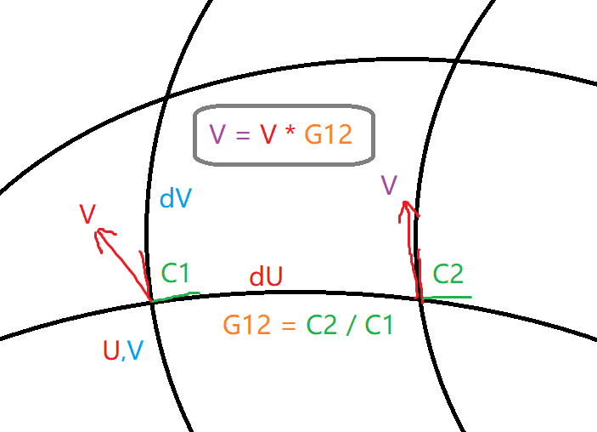To move in any direction of the differential vector:

Arbitrary differential vector:

dW = Cw * dU

So move in any direction of the differential vector:

V2 = V1 * Gw = V1 * Gu * Cw

where: Gu = G12 = C1 / C2

This quotient represents two coordinate system objects in the direction of the unit differential vector dU.

###### Curvature calculation

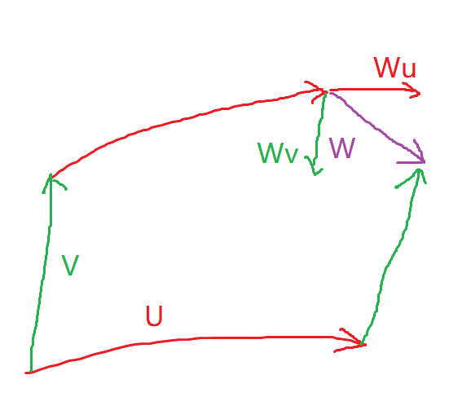

When observed under a curved coordinate system, the parallel line projection of the x- and y-axes of the natural coordinate system results in the g12 curve. This curve corresponds to Gu and Gv in two directions, respectively, from (u1,v1) to (u2,v2). To calculate the difference between the two paths plus the correction term, we use the curvature formula:

Ruv = Gu*Gv - Gv*Gu – G[u, v]

## Combination with Lie groups, Lie algebras

The rotation matrix R is an element of the Lie group, and the multiplication operation of our coordinate system is equivalent to the rotation matrix, so our coordinate system C is also an element of the Lie group, multiplication is the operation, and the 0 element is ONE:

C∈ {ONE, (*)}

The vector fork multiplies the corresponding coordinate system

v1 X v2 = v*C1 X (v * C2)

Let v = vec3. ONE is vec3(1,0,0), then C * v = C, so the above equation can be written as:

v1 X v2 = v*(C1 X C2)

We define a coordinate system fork multiplication operation , expressed in Lie algebra brackets :

[C1, C2] = C1 * C2 – C2 * C1;

## Combination with Lie groups, Lie algebras

The rotation matrix R belongs to a Lie group, and the multiplication operation of our coordinate system is equivalent to the rotation matrix. Therefore, our coordinate system C is also a Lie group element, with multiplication as its operation and ONE as its identity element:

C∈ {ONE, (*)}

The vector fork multiplies the corresponding coordinate system

v1 X v2 = v*C1 X (v * C2)

Let v = vec3. ONE is vec3(1,0,0), then C * v = C, so the above equation can be written as:

v1 X v2 = v*(C1 X C2)

We define a coordinate system fork multiplication operation , expressed in Lie algebra brackets :

[C1, C2] = C1 * C2 – C2 * C1;

## Conclusion

The coordinate system object can simplify the linear operation in local space, and some operations can be appropriately designed when calculating vector movement and rotation operations, and a unified form can be formed according to the rules of group theory. It can be applied to situations that require a lot of linear operations, such as constraint calculations. Vectors, matrices, and tensors are combined through coordinate system objects, and Lie groups and Lie algebraic objects are unified into a ring, forming a unified and coherent form.